**OUTPUT SCREEN**

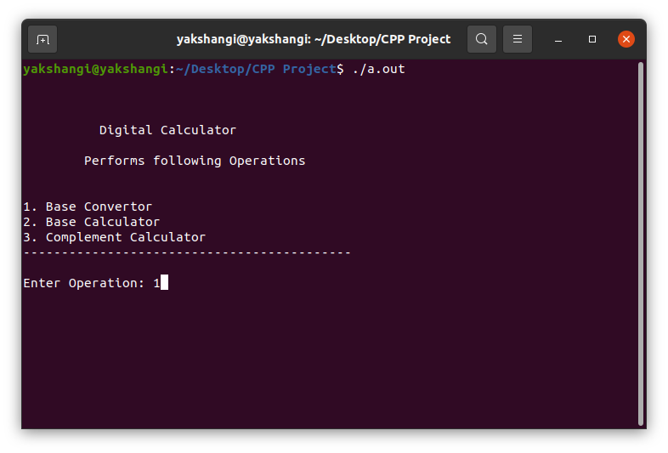

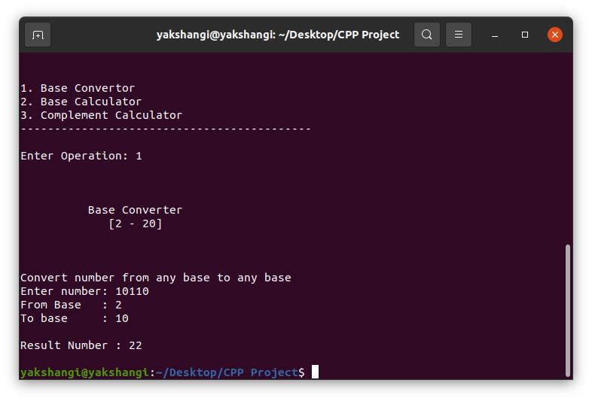

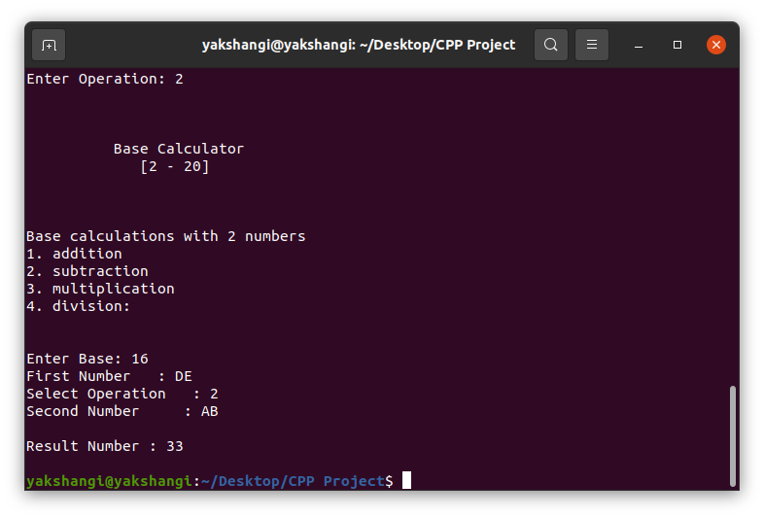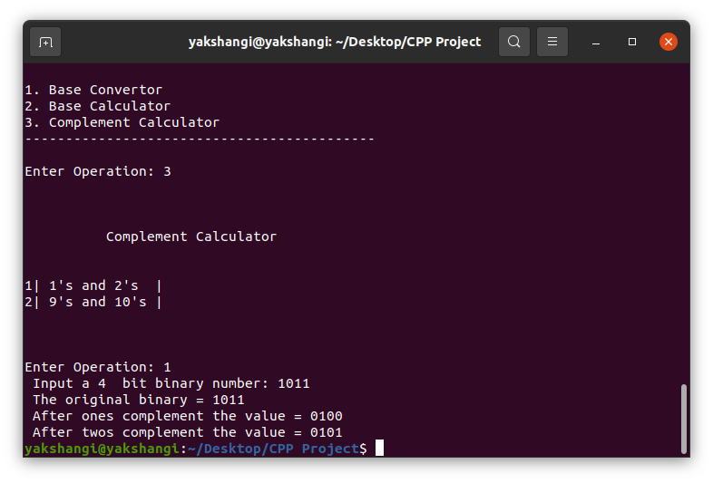

**Future Scope:**

* Further Implement:

1. (R-1) ‘s and R ‘s complement
2. Weighted binary codes
3. Non - Weighted binary codes
4. History